1.A company is analysing the salaries of its employees. Apply your understanding of Univariate EDA to calculate and compare the mean, median, and mode of the salary distribution. Discuss the implications of any disparities between these measures. Write R code to calculate the mean, median, and mode of the salary distribution and interpret the results in the context of employee salaries.

Output:

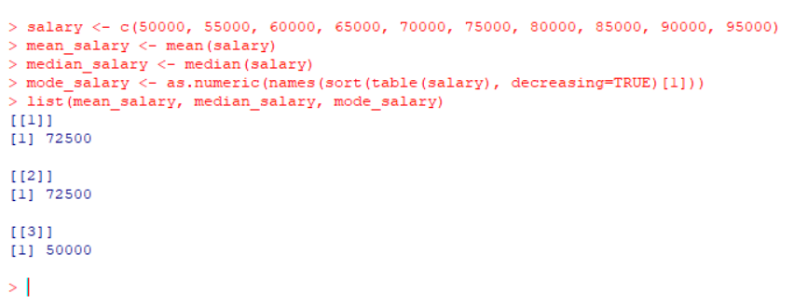

2. Poisson Regression Analysis.

Output:

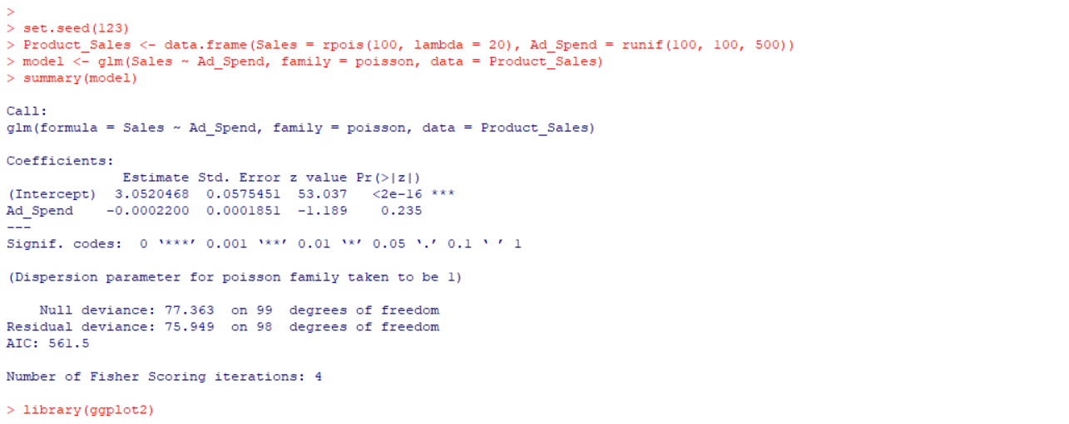

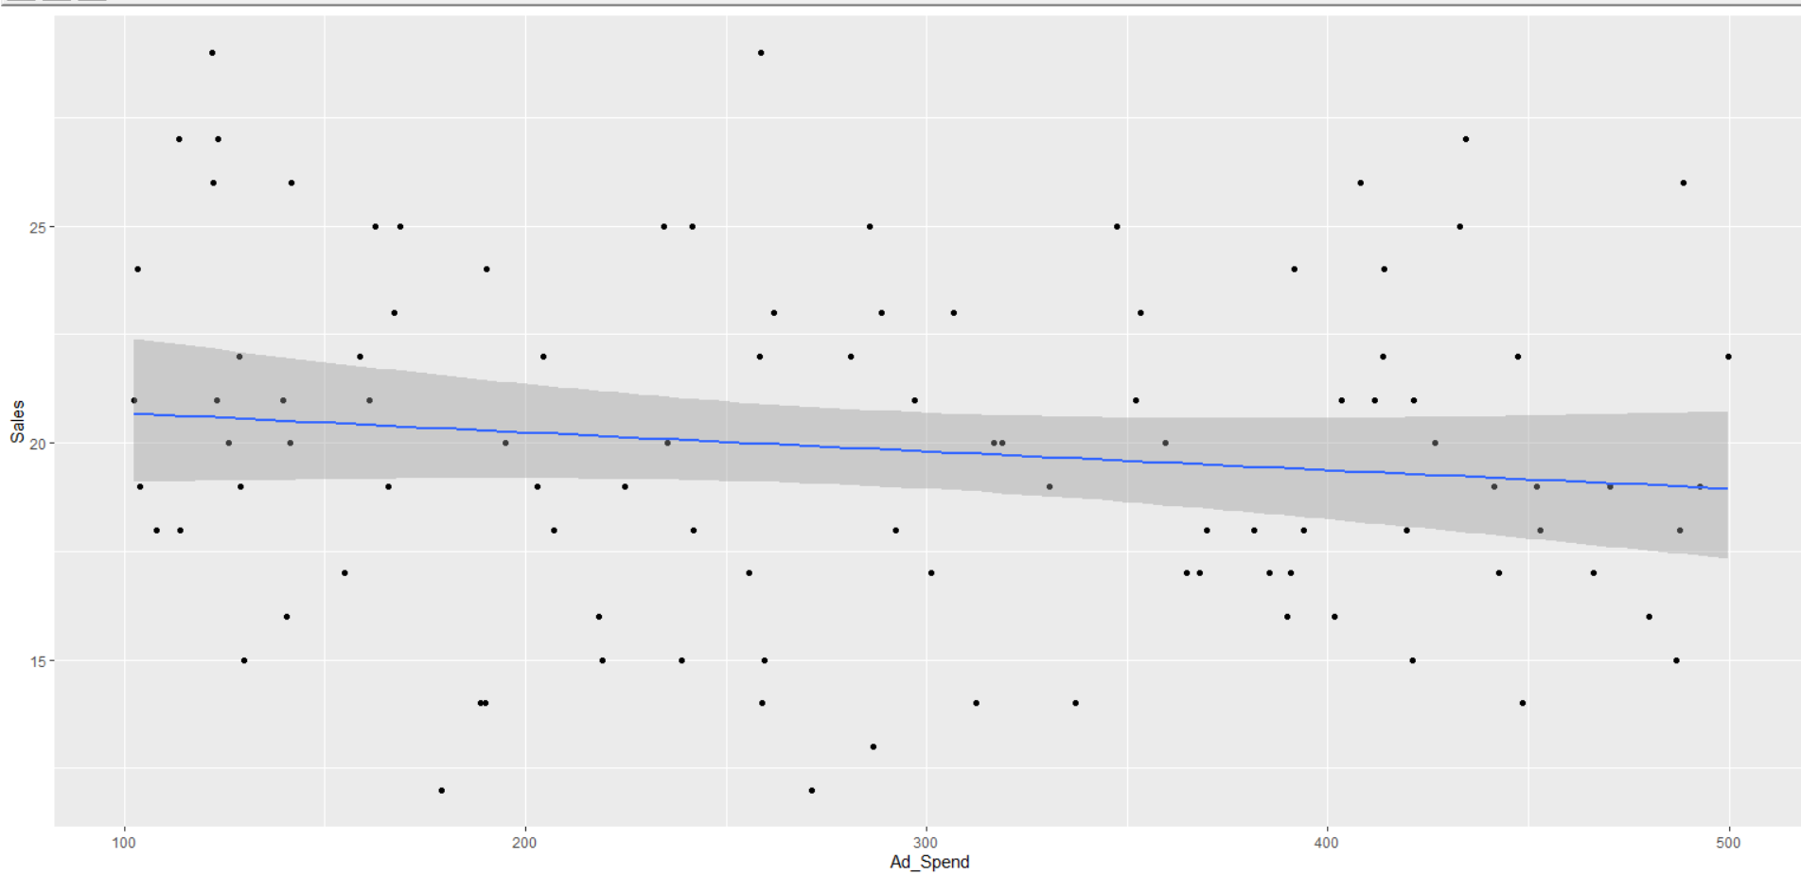

3. Lattice vs ggplot2 Visualization.

Output:

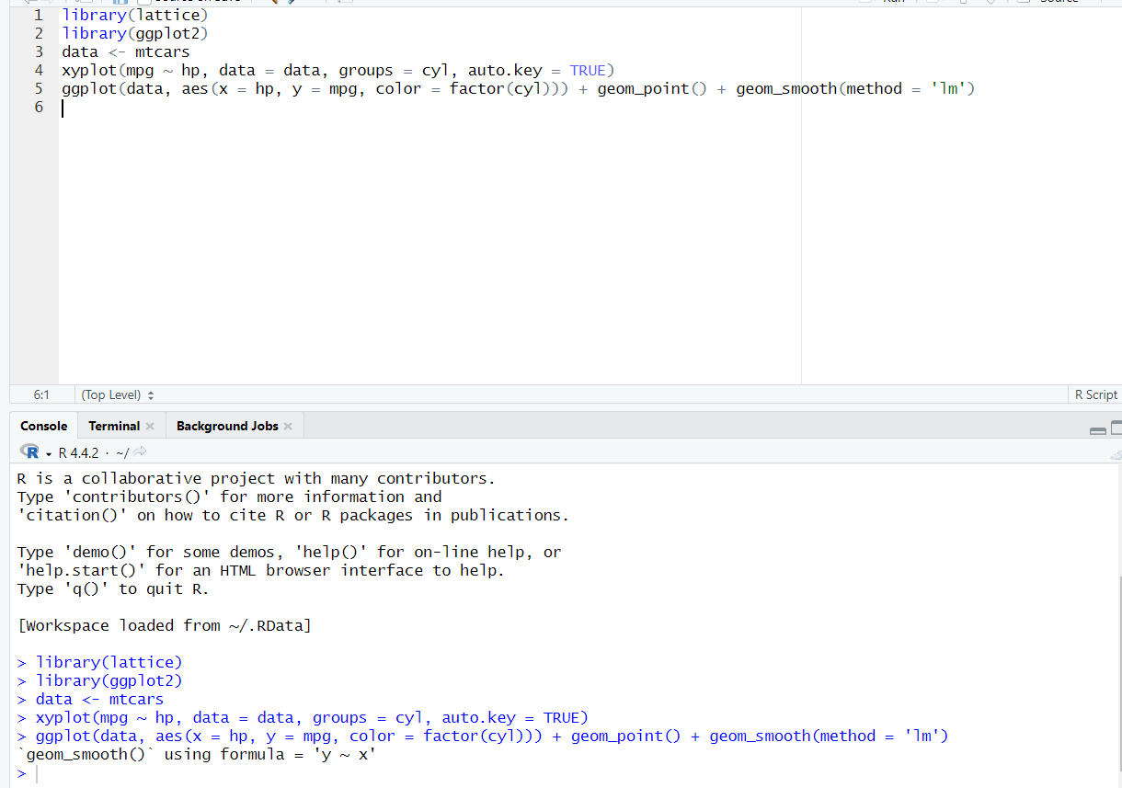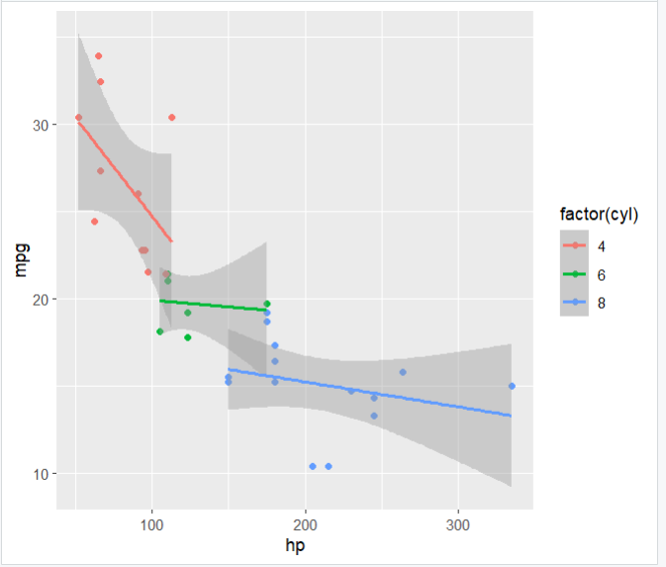

4. Student Scores Matrix.

Output:

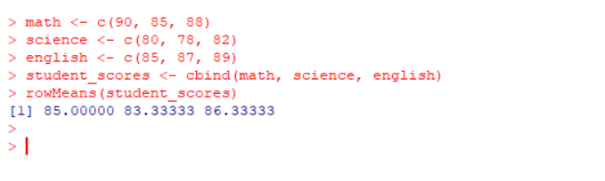

5. Melting and Casting in R.

Output:

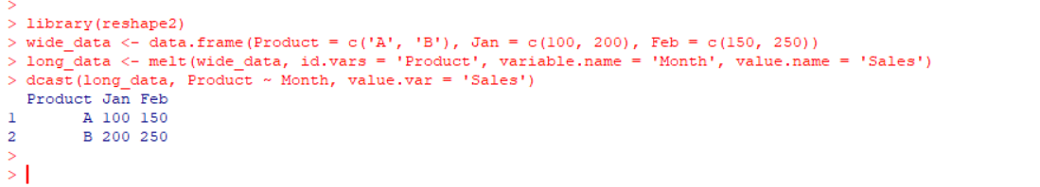

6. Regression Model for Sales & Spends.

Output:

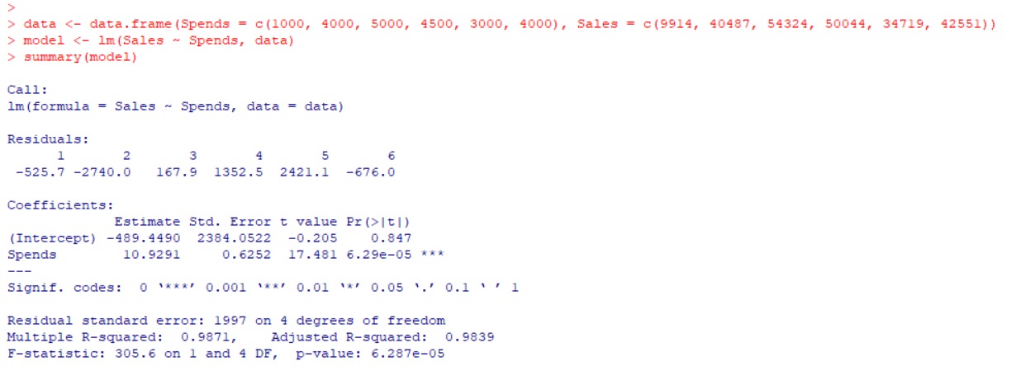

7. Temperature Analysis

Output:

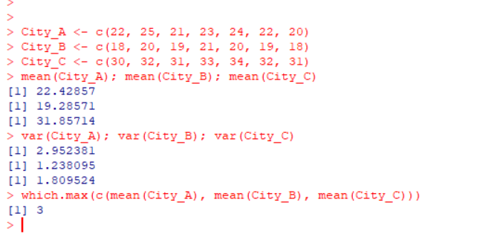

8. Univariate EDA on Salary (Repeated)

Output:

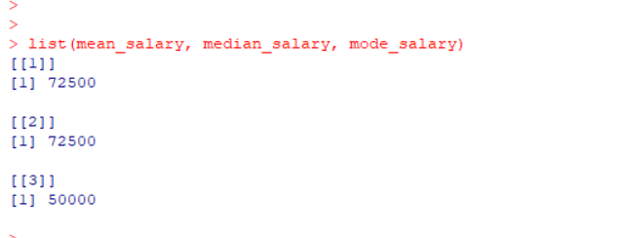

9. Data Frame Operations

Output:

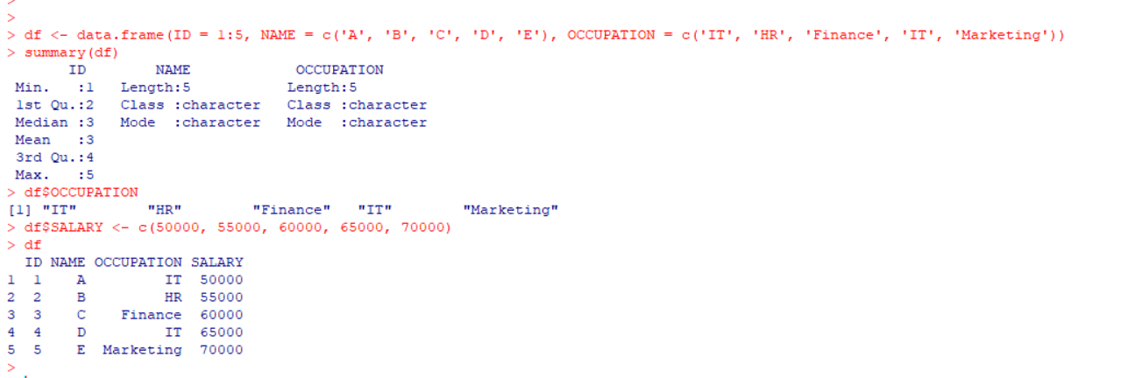

10. CSV File Operations

Output:

